

**SERVICES**

**The Praetors**

CONTENTS

1 AI AND ML DEVELOPMENT SERVICES 2

# AI AND ML DEVELOPMENT SERVICES

**META TITLE**: Custom AI & ML Development Solutions | The Praetors

**META DESCRIPTION**: Leverage AI and ML development services to automate routine tasks, enhance your decision-making, and identify business opportunities.

**URL**:

**[BANNER 1]**

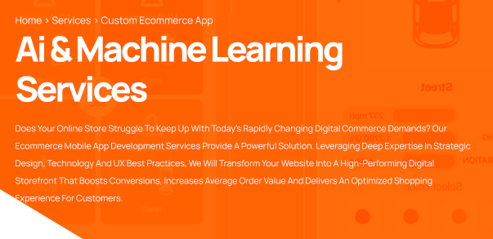

**LEADING AI & ML DEVELOPMENT COMPANY**

The Praetors is a leader in developing tailored artificial intelligence and machine learning solutions. We take a consultative approach, thoroughly understanding each client's specific needs and objectives. Our skilled practitioners then design and implement optimized modeling approaches. This collaborative process enables organizations across industries to realize enhanced performance through the application of advanced technological capabilities.

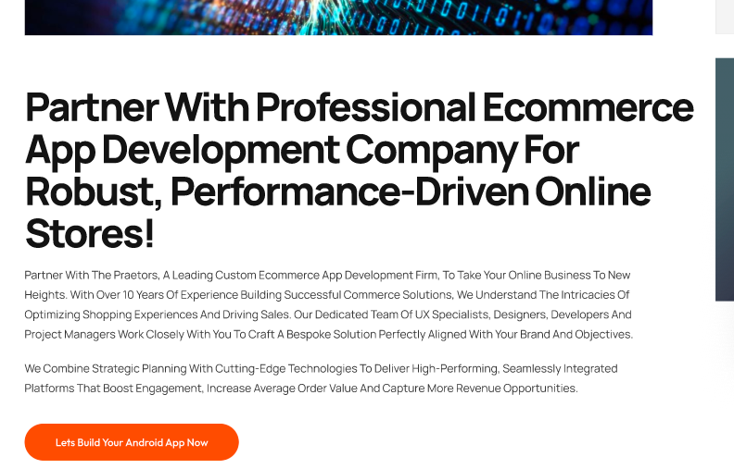

**Driving Competitive Advantage For Businesses with AI and ML-Powered Development Solutions and Strategies**

The Praetors understands that in today's technology-driven business environment, those who can extract intelligent insights from data will gain a decisive competitive edge. That's why we make it our mission to drive competitive advantage for organizations through customized artificial intelligence and machine learning solutions. By taking a consultative approach to deeply understand your goals, operations, and industry challenges, our experts strategically develop predictive and optimization models tailored precisely to your unique needs.

Whether you seek to augment human decision-making, enhance processes and efficiency, or uncover new growth opportunities, The Praetors provides custom AI and ML development solutions to drive your success in the marketplace.

**[GET STARTED]**

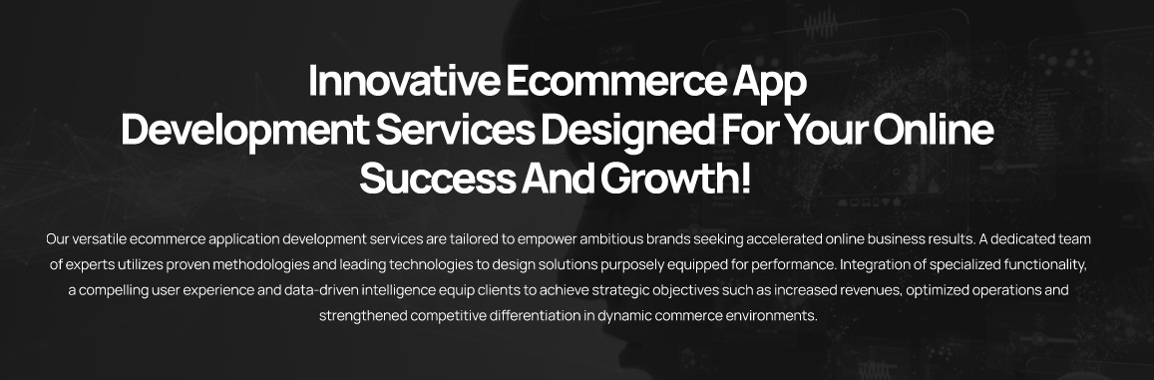

**Partner with The Praetors To Transform Data into Competitive Differentiation Through Purposeful Artificial Intelligence.**

Global enterprises across all sectors have successfully leveraged our machine learning and artificial intelligence development expertise. Through a consultative process, we engineer customized solutions to establish reliable data-driven decision support systems, automate manual workflows, and continuously refine operations. Whether optimizing supply chains, enhancing customer experiences, or gaining deeper insights, clients benefit from our strategically designed predictive and optimization models. Integrating advanced analytics capabilities, we provide a strategic foundation for clients to gain competitive advantage through intelligent, automated processes and enhanced productivity.

|  |  |
| --- | --- |
| **Computer Vision**  The Praetors applies cutting-edge computer vision engineering to develop strategic visual analytics platforms. Our specialized systems can accurately recognize objects, facial details, and gestures and perform progressive image and video examinations. These capabilities enable applications in autonomous systems, including self-driving vehicles and industrial robots. | **Natural Language Processing (NLP)**  We also design sophisticated natural language processing tools to drive intelligent process automation across sectors. Our NLP-powered solutions optimize functions for search platforms, customer workflows, in-vehicle infotainment, and clinical decision-making. Core technologies involve machine translation, conversational modeling, and speech pattern analysis. |
| **AI Chatbot Support**  Employing premier methodologies in AI assistant design, The Praetors crafts tailored conversational interfaces. Our dialogue agents seamlessly analyze user exchanges, comprehend subtleties, and respond contextually across channels. Continuous machine learning allows the virtual assistants to progressively learn from interactions and provide predictive recommendations. | **Voice and Speech Recognition**  The Praetors further offers comprehensive speech and voice recognition services. Our technologies structurize audible inputs to facilitate search-friendliness and usability. Clients in industries like healthcare, transportation, and customer service benefit from modernized operations and enhanced consumer experiences. |

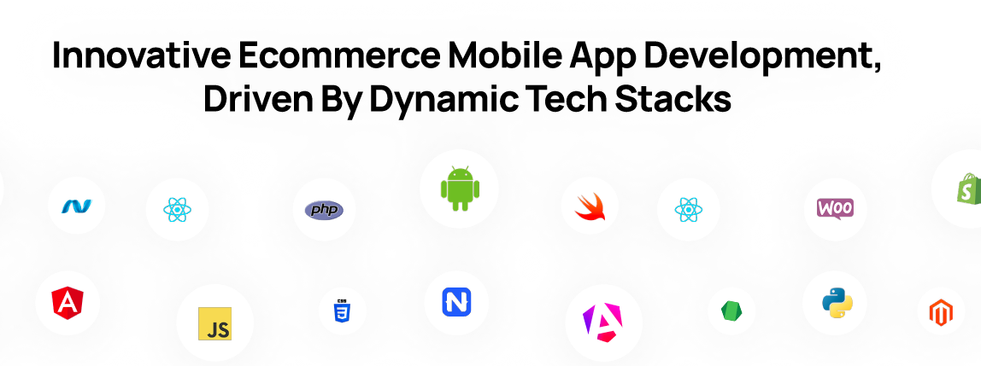

**Supercharge Your Business with our Custom AI & ML Development Solutions Driven By Dynamic Tech Stacks**

**[TECH LOGOS HERE]**

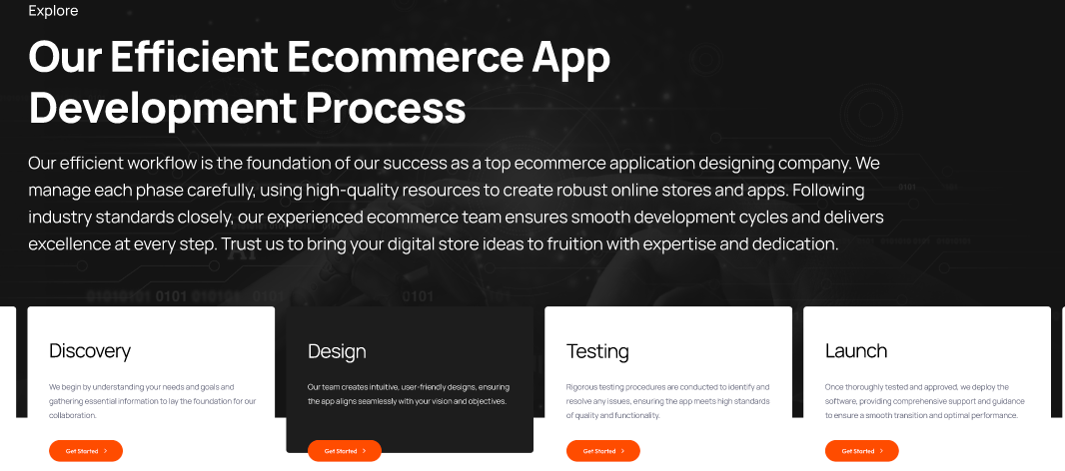

**Explore**

**Our Robust AI & ML Development Process**

The Praetors leverages a comprehensive AI and machine learning development methodology to consistently deliver optimized solutions. Through a robust multi-stage process entailing problem definition, data collection, model training, and continuous enhancement, we engineer intelligent applications calibrated for long-term success.

|  |  |
| --- | --- |
| **Problem Definition** | Comprehensive analysis of key objectives, operational chokepoints, and target datasets through consultative discussions to define the problem statement and scope. |
| **Data Collection** | Strategic sourcing of high-quality training inputs and labeling using manual and automated techniques to ensure model generalizability. |
| **Model Training** | Application of iterative prototyping and algorithm experimentation to identify techniques best addressing the unique problem and efficiently learn patterns from the curated data. |
| **Testing and Validation** | Rigorous testing and validation combining performance metrics, expert reviews, and user feedback to refine the model for real-world deployment meeting specified goals. |
| **Continuous Enhancement** | Seamless integration within your technology systems and commitment to continuous learning from newly generated data via retraining to sustain competitive differentiation over time. |

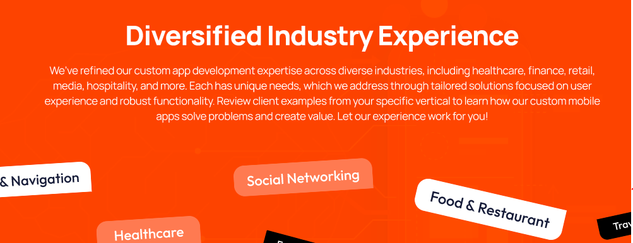

**Diversified Industry Experience**

As a leading AI & ML development company, The Praetors has attained extensive AI/ML deployment experience across various industries through countless successful initiatives. Our practitioners hold deep contextual know-how of diverse business domains, challenges, and demand drivers. This comprehensive cross-sector exposure informs strategic consulting efforts, fuels intelligent solution design with applicable insights, and equips us to seamlessly assist global enterprises leveraging data-centric transformation to optimize functions, capture opportunities, and cement competitive positions.

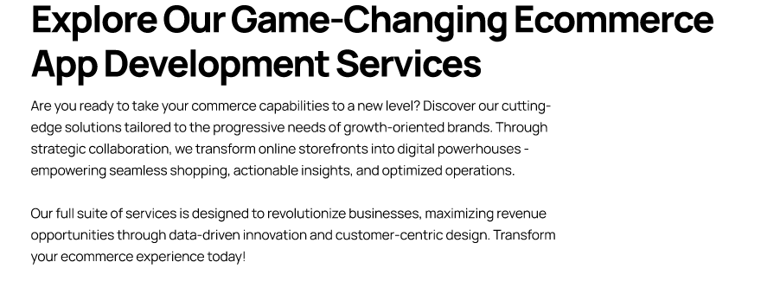

**We Believe in Intelligent Development and Smarter Outcomes Through Precision Solutions with AI and ML Technologies!**

At The Praetors, our expert team pairs expertise with smart tech and advanced algorithms to transform your data into actionable insights. We provide custom solutions that drive innovation, increase efficiency, and ensure a competitive edge. Committed to delivering measurable results, we help businesses navigate complex challenges and unlock new opportunities.

With our focus on quality and customer satisfaction, we empower organizations to harness the full potential of our AI and ML development services. Partner with us for a more innovative, data-driven future where intelligent solutions lead to better business decisions and growth.

|  |  |  |
| --- | --- | --- |
| **Actionable Insights**  Through sophisticated AI-driven analysis of enormous volumes of structured and unstructured data beyond human cognitive capabilities, The Praetors' solutions can detect hard-to-find patterns and derive insights to guide major strategic decisions, product development initiatives, and long-term business planning with high accuracy and reliability. | **Increased Operational Efficiencies**    Leveraging machine learning and natural language processing, The Praetors designs and implements customized robotic and digital process automation solutions to streamline repetitive manual workflows, optimize business systems and asset utilization, free up employee bandwidth for more innovative activities, and help clients achieve unmatched levels of productivity, quality, and speed to market. | **Personalized**  **Experiences**  By developing and deploying AI chatbots, virtual agents, predictive recommendation engines, and other individualized solutions, The Praetors enables enterprises to provide hyper-relevant, frictionless experiences tailored to each customer's unique preferences, behaviors, and goals; this advanced personalized attention strengthens client relationships and satisfaction at scale. |

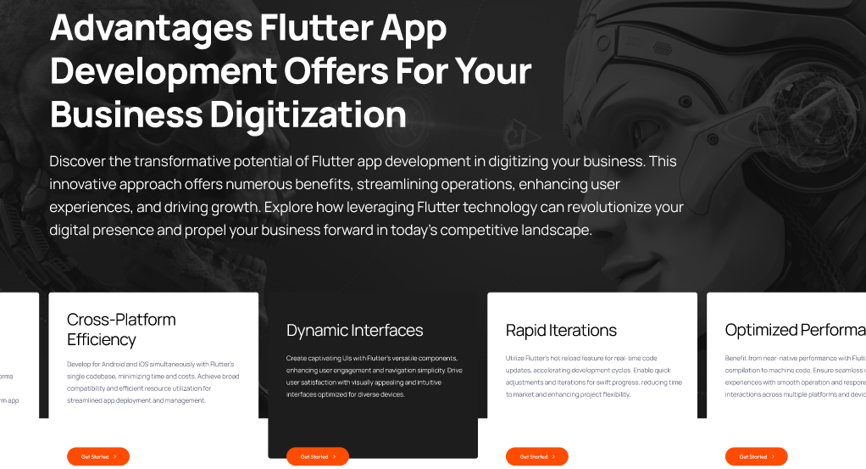

**[REMOVE THIS SECTION. REPEATED MANY TIMES]**

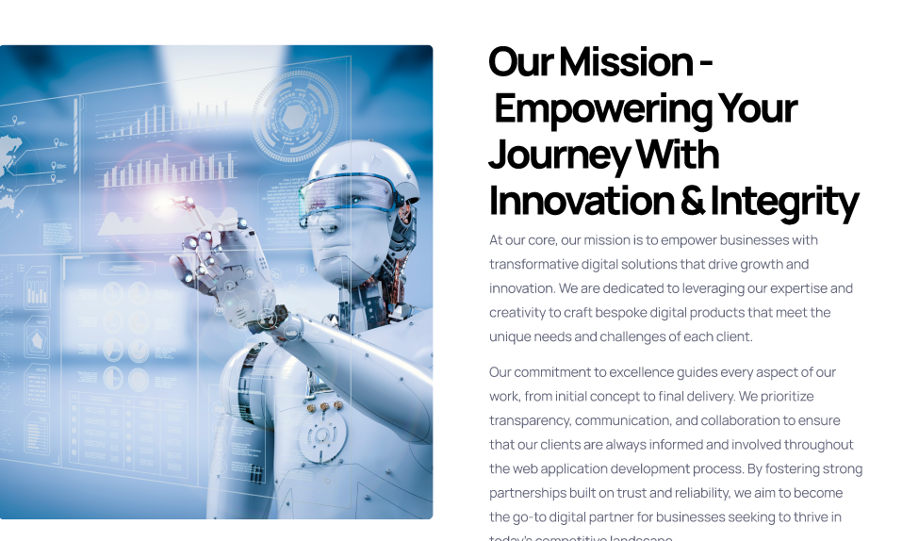

**Benefits of Custom AI & ML Development Solutions for Businesses**

Implementing artificial intelligence and machine learning applications provides numerous competitive advantages for forward-thinking organizations. Automating repetitive tasks and decisions through innovative technologies allows businesses to streamline workflows, reduce costs, and refocus human capital onto higher-value activities. Data-driven insights also empower evidence-based strategic decision-making and new revenue streams. AI can optimize resource allocation and predict and avoid issues before they impact operations.

Adopting AI solutions further enhances customer experiences and engagement. Intelligent interfaces tailored for individual preferences and behaviors cement loyal relationships. Adaptive systems contextualize information to serve clients more efficiently. As newer technologies emerge, companies delivering enhanced experiences and value through AI will gain strong footholds in their industries and unlock exponential growth opportunities.

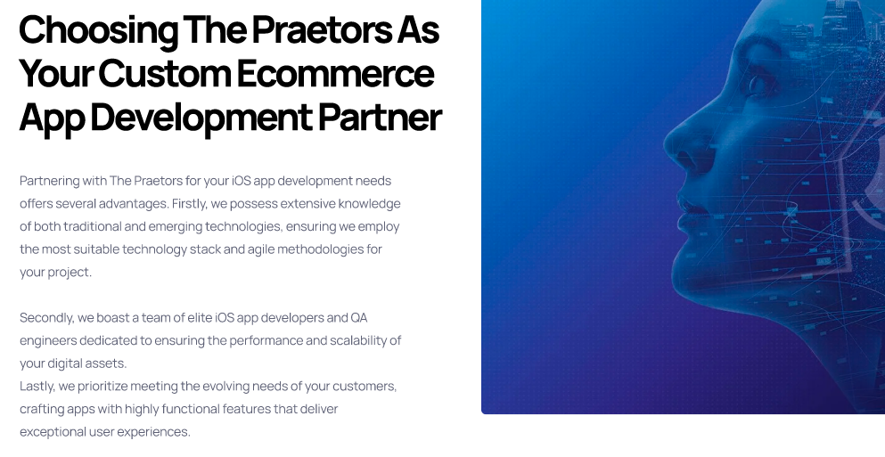

**Choosing The Praetors As Your AI & ML Development Services Provider**

The Praetors is the ideal partner for businesses seeking a full-service AI solutions provider. With years of experience conceptualizing, designing, and implementing intelligent applications across industries, the company has an unparalleled depth of quantitative and qualitative expertise. A meticulous 5-step methodology ensures optimized outcomes that address specific objectives.

Customers benefit from dedicated teams guiding projects from start to finish. Rigorous testing combines with ongoing monitoring to refine models for real-world deployment and sustained ROI. Post-launch enhancements harness new insights. Seamless integration futureproofs technology investments. As an innovative leader staying ahead of the curve, The Praetors delivers lasting competitive differentiators through intelligent decision-making tools calibrated for any organizational vision.

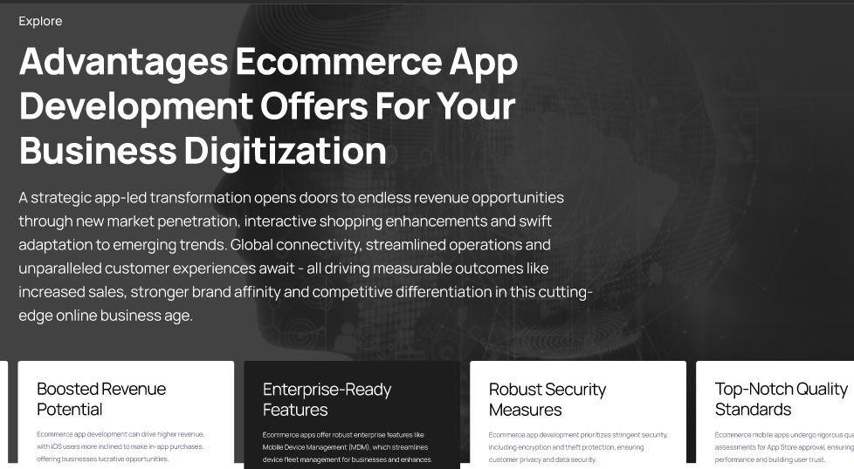

Advantages

**Achieve More with The Praetor’s Reliable AI and ML Development Services**

When you partner with The Praetors for AI and machine learning development, your business gains a reliable ally in data-driven transformation. Our specialized teams deploy proven methodologies to craft solutions addressing unique goals and operational complexities. Through intelligent applications designed, implemented, and enhanced via ongoing support, you empower teams, streamline processes, and uncover opportunities with insights from vast information reserves. Our services reliably optimize key performance metrics and cement long-term competitive resilience through scalable, futureproofed innovation.

|  |  |  |
| --- | --- | --- |
| **Increased Productivity and Efficiency**  We implement robotic process automation and workflow management solutions to optimize business operations. Automating repetitive tasks allows employees to focus on higher-value work, enhancing overall productivity. | **Personalized Customer Engagements**  Our data-focused solutions powered by AI and machine learning analyze user behavior and preferences to deliver customized experiences. We help clients better understand customers and strengthen relationships. | **Streamlined Data Integration**  We develop effective extract, transform, and load procedures to seamlessly share information across systems and platforms. Consistent data accessibility and management boost strategic decision-making. |
| **Deeper Customer Insights**  Our AI/ML experts craft engaging interfaces tailored for each user. Leveraging tools like CRM solutions, we help track customers to improve satisfaction and long-term loyalty. | **Actionable Business Intelligence**  Using sophisticated algorithms, we transform massive data volumes into actionable intelligence. Accessing insights from analytics platforms empowers data-driven growth planning. | **Scalable Innovation**  Flexible AI/ML applications built on scalable cloud architectures adapt nimbly to changes. Virtual infrastructures efficiently manage information to fuel continuous innovation. |

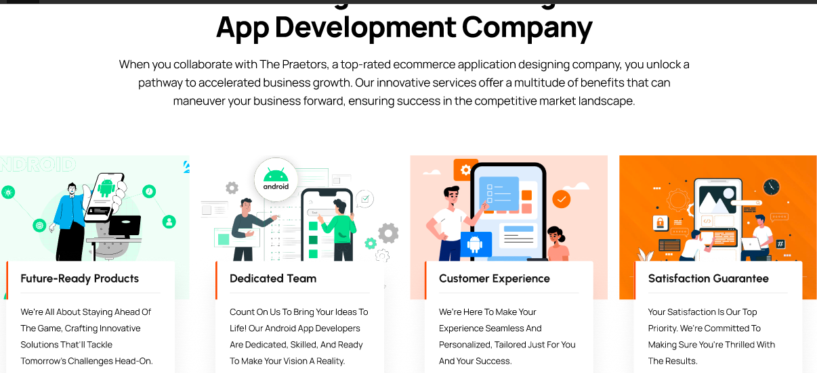

**Perks of Partnering with A Professional AI & ML Development Company**

Partnering with a professional AI & ML development company unlocks a wealth of benefits. From strategic guidance and custom solutions to cutting-edge technologies and seamless integration, you gain expertise, efficiency, and a competitive edge to achieve your business goals.

|  |  |
| --- | --- |
| **Strategic Guidance & Expert Insights**  Leverage our years of experience in AI and ML to gain valuable insights and strategic guidance, enabling your business to stay ahead of the competition. | **Access to Cutting-Edge Technology, Tools, & Platforms**  Our team has extensive experience with the latest AI and ML technologies, tools, and platforms, allowing us to deliver customized solutions to meet your specific business needs. |
| **Data-Driven Decision-Making Capabilities**  Harness the power of AI and ML to make informed, data-driven decisions, enabling your business to optimize processes and improve overall performance. | **Enhanced Customer Experiences & Satisfaction**  Utilize AI and ML-powered solutions to deliver personalized, seamless customer experiences, driving increased customer satisfaction, loyalty, and retention. |

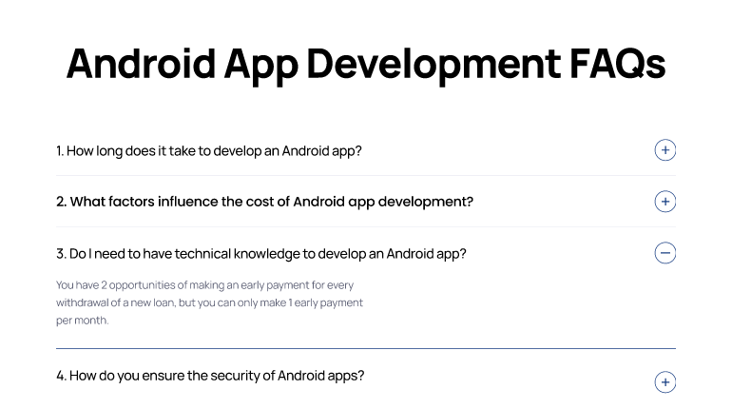

**AI & ML Development Services – FAQs**

**What types of projects can AI/ML development services help with?**

AI and machine learning experts can assist with various initiatives, including predictive analytics, automated decision-making, natural language processing, computer vision, forecasting, optimization, and more.

**How much does it cost to develop an AI/ML solution?**

The cost of developing an AI/ML solution can vary significantly depending on factors like project scope, data needs, required technologies, and timelines. Clients are recommended to discuss their requirements for a customized quote.

**What are the benefits of outsourcing AI/ML development?**

Outsourcing to experts allows for leveraging advanced skills, staying up to date with innovations, and gaining access to dedicated resources - reducing costs and risks compared to internal development.

**How long does it take to develop an AI/ML model?**

Model development time depends on the complexity of the goals, algorithms selected, and data preparation requirements. Simple proofs-of-concept may be ready within weeks, while advanced solutions involving large datasets and custom tools can take several months to properly implement and validate.

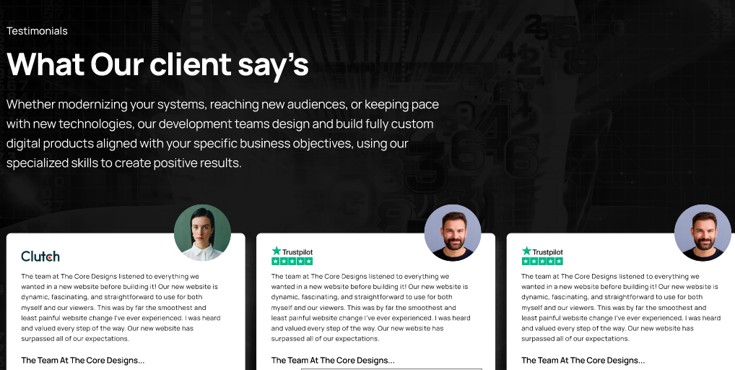

Testimonials

**Here’s What Our Clients Say**

Hear first-hand from satisfied clients how our AI/ML development services have delivered tangible results. Glowing reviews highlight transformed operations through streamlined processes, increased revenues from predictive insights, and deepened relationships underpinned by personalized engagements.

*The Praetors' customized demand forecasting model far exceeded our expectations. Inventory is perfectly aligned with sales patterns, slashing carrying costs by 20%. I'm impressed by their expertise and professionalism.*

**Natalia Owens**

*Since implementing their recommendation engine, our website visits are up 30% as visitors consistently find highly relevant products. Their intuitive dashboard provides insights to constantly refine our strategies. It's clear they truly understand our business.*

**Thomas Sylvester**

*As a manufacturing firm striving for efficiency, The Praetors' quality control AI eliminated defect rates and sped up our production line. With their optimized predictive maintenance system, downtime has been reduced to almost zero. Their solutions clearly produce measurable results for us on the factory floor.*

**Jacob Vasquez**

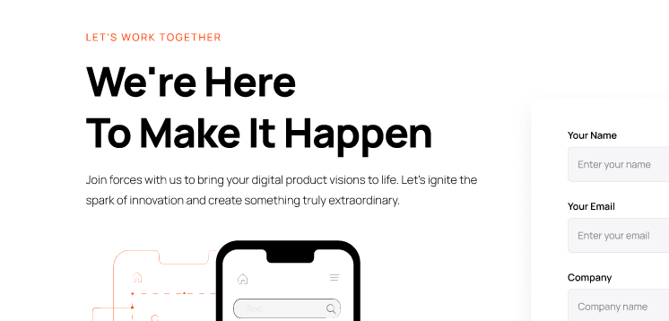

**Let’s Work Together**

**We’re Here To Make It Happen**

**[CONTACT FORM**